In the field of Computer vision there are three important tasks:

1. Image Classification
2. Object Detection
3. Image Segmentation

CNN Architecture:

1. RCNN Family ==> RCNN, Faster RCNN, Faster CNN, Mask RCNN
2. Single shot detector ==> YOLO, SSD
3. Centernet

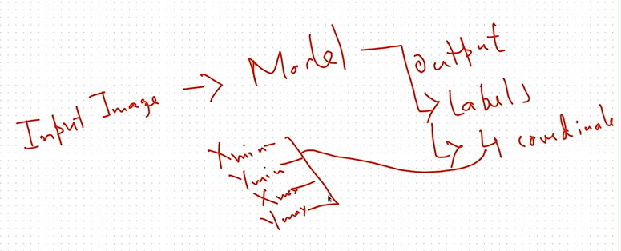

Along with the 4 coordinates the output will also be total no of detections and the confidence score.

Metrics for Object Detection:

1. TP, TN, FP, FN
2. Precision and Recall
3. IOU (Intersection over Unit) for predicted and ground truth

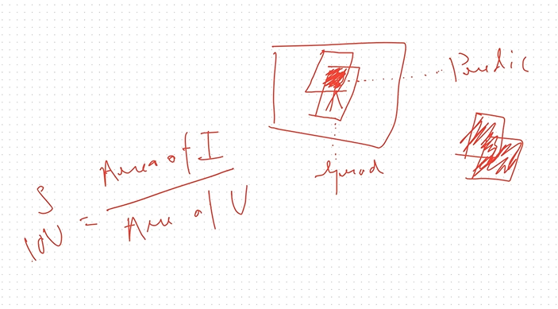

1. MAP (Mean Average Precision)